Student Name: __________________
Class and Section __________________
Total Points (15 pts) __________________
Due: Wednesday, Sep 12, 2012 before the class

Project: Counting the Occurrences of Words

CSCI 2410 Data Structures and Algorithms
Armstrong Atlantic State University

Problem Description:

Rewrite Listing 21.9 to read the text from a Web page. The URL for the Web page is passed as a command-line argument. Words are delimited by whitespace, punctuation marks (,;.:?), quotation marks (’”), and parentheses. Count words in case-insensitive fashion (e.g., consider Good and good to be the same word). The words must start with a letter. Display the output in alphabetical order of words with each word preceded by its occurrence count. Here is a sample run:

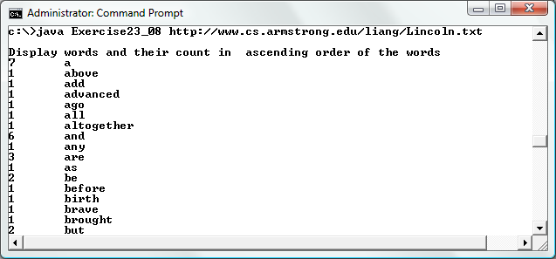

Please see page 551 for how to read data from a URL.

Analysis:
(Describe the problem including input and output in your own words.)

Design:
(Describe the major steps for solving the problem. How do you use recursion to solve this problem.)

Coding: (Copy and Paste Source Code here. Format your code using Courier 10pts)
Name the public class Exercise21_08

Testing: (Describe how you test this program)

Screen Shot

Use http://www.cs.armstrong.edu/liang/Lincoln.txt to test your program and give me a screen using this test source.

What to submit?

1. Compile and Submit to LiveLab (you must submit the program regardless whether it complete or incomplete, correct or incorrect)

2. Print this copy.

3. Fill in self-evaluation:

- Can your program display words only? _______________
- Can your program display words in increasing order? _______________
- Can your program count words correctly? _______________
- Can your program pass argument from the command-line? _______________

Solution:
import java.util.*;
import java.io.*;

public class Exercise21_08 {
public static void main(String[] args) {
if (args.length != 1) {
System.out.println(
"Usage: java Exercise23_08 URL");
System.exit(1);
}

// Create a tree map to hold words as key and count as value
TreeMap<String, Integer> treeMap = new TreeMap<>();

try {
java.net.URL url = new java.net.URL(args[0]);
Scanner input = new Scanner(url.openStream());

while (input.hasNext()) {
String line = input.nextLine();
String[] words = line.split("[ @!~{}\\[\\]$#^&*\n\t\r.,;?'\")(]");

for (int i = 0; i < words.length; i++) {
if (words[i].trim().length() > 0 && words[i].trim().matches("[A-Z|a-z]+")) {
String key = words[i].toLowerCase();

if (treeMap.get(key) != null) {
int count = treeMap.get(key);
count++;
treeMap.put(key, count);
}
else {
treeMap.put(key, 1);
}
}
}
}
}
catch (Exception ex) {
ex.printStackTrace();
}

// Get an entry set for the tree map
Set<Map.Entry<String, Integer>> entrySet = treeMap.entrySet();

// Display words in alphabetical order
System.out.println("\nDisplay words and their count in " +
" ascending order of the words");
for (Map.Entry<String, Integer> entry: entrySet)
System.out.println(entry.getValue() + "\t" + entry.getKey());
}
}

